STUDENT Joseph Roper

SALFORD CITY COLLEGE | FUTURE SKILLS

BTEC National Extended Diploma in Creative Media Production

UNIT 20: GAMING SOFTWARE

Unit 20 – Task 3

# Platform Dependency

Platform dependency is when certain software and applications can only run on a fixed operating system. An example of this is with the Nintendo Wii as on this you can only insert and run Nintendo licensed disks as if you put a DVD in the system it will not run and just eject the disk as it is not supported by the Wii’s operating system. Companies make their games and consoles platform dependent so that their system can have exclusives, for example, Nintendo’s consoles only sell because of their famous exclusives with Mario and Zelda as the only way to play these fun titles is by owning a Nintendo system. Personally, I don’t really see anything wrong with platform dependency as it is up to the developers of the game to decide which system they want it on and I also feel like without platform dependency companies wouldn’t strive to innovate their games and make them better as I feel it will weaken the competitiveness of the gaming economy.

[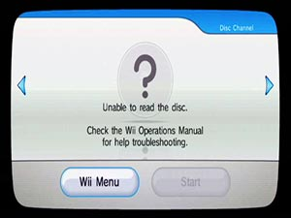](http://www.ausgamestore.com/wii/wii-dvd-drive.html)[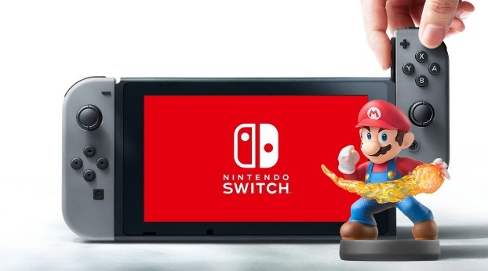](https://gamerant.com/nintendo-switch-amiibo-support/)

# Operating Systems

An operating system is a piece of software that allows the user to run other programs on it. For example, Windows is an operating system and you can run the application Google chrome to search across the internet. A good operating system will include an easy to understand user interface allowing a beginner to use the device effectively so that you are not looking everywhere in the system settings trying to find out how to turn the volume up. An example of a good user interface is with the Windows operating system as it has a volume icon in the bottom right of the screen which when clicked allows you to turn up the volume. A bad operating system will contain a lot of bugs and frequently crash, these bugs could be easily fixed with an update, but a bad operating system will not be updated as the developers of the system won’t put in the time to work on fixing the system.

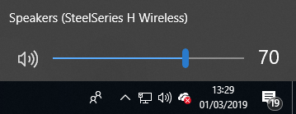

# Drivers Needed

Drivers are pieces of software that are downloaded onto your operating system that allows your computer to communicate with the device plugged into the computer. Once the device's driver is downloaded you can then control it for example if you plugged a mouse into your computer the device's driver would download onto the operating system allowing the mouse to then communicate to the computer so that if you move your mouse the icon on the computer will move too.

[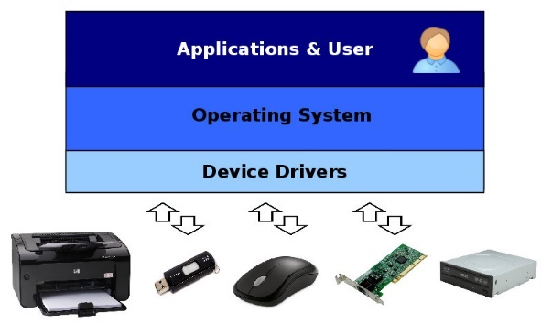](http://xmodulo.com/linux-vs-windows-device-driver-model.html)

# API

Application Programming Interface or API for short is a set of protocols to be used as a tool for building software applications. Many companies will release their API’s to the public so that other companies can create software to be displayed on the internet including companies’ websites that will help sell the both their product and the company that provided the API with free advertisement. For example google released API’s for many of their businesses such as YouTube which allows people to embed YouTube Videos into their websites which will play on the website as well, this can help business owners as if they are selling something on their website they can embed a YouTube video that reviews the product in a positive light on their website and this will also provide YouTube and google with free advertising as it displays the YouTube logo in the corner of the video.

[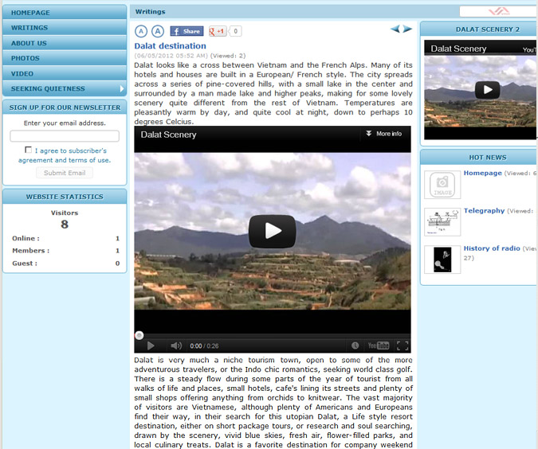](http://cms.vnvn.com/a334/24-to-embed-a-youtube-video-in-your-website)

# API Languages

API languages or otherwise referred to as programming languages help users communicate with their computer and different software and applications on the device. Programming languages make it easier for people to write code which the computer can understand and run effectively while also making it easy to interpret what the code will do for the user. Each API language uses different wording to define functions such as creating a variable, this is because each creator of anew language finds that their language is the easiest to use or provides the fastest run times as the code is broken down more making it easier for the computer to understand. This is noticeable when you look through different languages and compare the method of printing out text for example in Python you will just type “ print (“Hello World”) ” and then run the program however in C++ you would have to type what is in the picture below which is a lot harder to remember than the Python method as it is broke down more for the computer making it harder to interpret for the user. C++ is one of the main API Languages as it is one of the oldest, making it the most well-known as it has been taught for longer. Compared to Python some would say C++ is better as it has more utility and is more well-known meaning most software will use it however Python is easier to learn and interpret for programmers.

[](https://strategisminc.com/courses/python-programming-training-fremont/)

[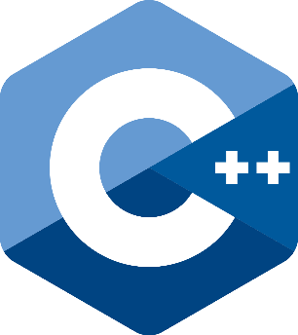](https://en.wikipedia.org/wiki/C%2B%2B)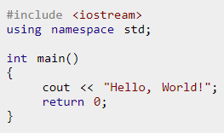

# Graphical API

An API is basically the middle man that helps two programs communicate with each other. An example of this is with the widely popular online video game store called Steam. In Steam, you can buy a game, but you don’t actually buy the game you buy a product key that lets you install the full game off Steams server. Steam is the API as when you buy a game the product key makes it so that your computer can communicate to the game for it to download to your computer.

DirectX is a built-in system that contains a collection of APIs’ for the computer to use to communicate to certain programs for example; audio, video and games direct sound. DirectX comes free with Windows and can only be used if your operating system is windows and because DirectX is so good and beats all the other competition most computers run Windows as their operating system rather than something like Linux that uses OpenGL instead of DirectX.

OpenGL stands for Open Graphics Library and is a free graphics API used in operating systems such as Linux, it helps the computer access GPU (Graphics Processing Unit) from this OpenGL will be able to access its built-in graphical functions such as; antialiasing, texture mapping, pixel operations and atmospheric effects like fogging and smoke. OpenGL is also open source meaning people will be able to change the code of the API to help improve it although sometimes people will change it to try and hack into the computers operating system or even games.

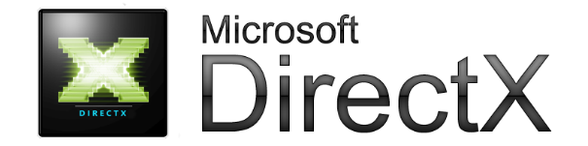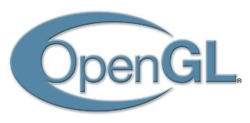

# Sound/Audio API

API’s are tools used for helping software communicate with each other therefore a sound API will act as a tool to help an application play audio. Currently, there are two main sound API’s used at a professional level, these are Java Sound API and Open AL. Open AL stands for Open Audio Library however the API is not opensource meaning the internal configurations in the API cannot be changed by the public. The API is cross-platform and is designed for rendering 3D positional audio basically surround sound. The API holds a bug library of 3D surrounds which when added to a game will add realism by simulating the degrading of sound over distance otherwise known as the Doppler effect. Java sound API allows users to access Open AL through Java.

[](https://en.wikipedia.org/wiki/OpenAL) 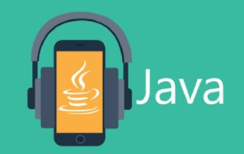

# TV Software

Televisions nowadays come with built-in operating systems that allow the device to work like your phone and stream online media, these TV’s are referred to as smart TV’s. The operating system used for smart televisions is usually a form of the android operating system with the own tv companies skin on the android layout to make it look like their own they will also change things like sound effects which apps can be downloaded on the TV for example on my Samsung smart TV I can’t download games as they won’t be able to run with the televisions hardware so I am only allowed access to media streaming apps such as Netflix, YouTube and BBC iPlayer. Television that are not smart and cannot access the internet can use external hardware to turn them into internet streaming devices, the main products that allow this are the google Chromecast, amazon fire tv stick and the ROKU. These devices will get plugged into the back of your TV into the HDMI port and will then be operated by an external controller paired with the device and will stream media from the internet to your TV. The advantage of these devices is that you can turn any monitor or TV into a media streaming device however a disadvantage is that you will have another remote to get lost on your coffee table or couch and usually smart TV’s will operate faster and have more seamless transitions from online streaming to normal television.

[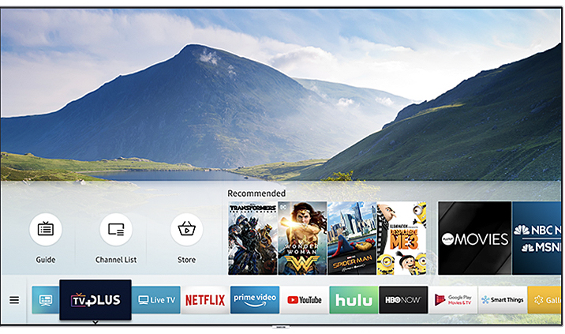](https://news.samsung.com/us/enhancing-samsung-smart-tv-security-new-firmware-updates/) [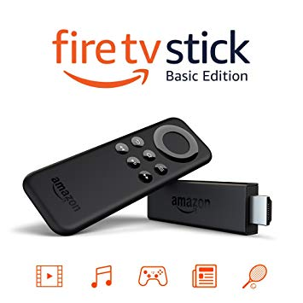](https://www.amazon.com.au/Fire-TV-Stick-Basic-Edition/dp/B01ETRGDV4)[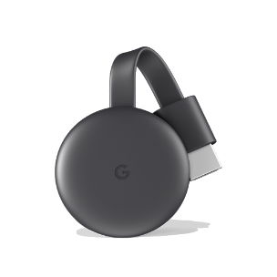](https://www.google.com/url?sa=i&source=images&cd=&cad=rja&uact=8&ved=2ahUKEwi1lKXaiOHgAhVT8OAKHZU_DgMQjRx6BAgBEAQ&url=https%3A%2F%2Fstore.google.com%2Fproduct%2Fchromecast&psig=AOvVaw3MLIW6J-iHyViVjZTRrlR0&ust=1551534000761084) [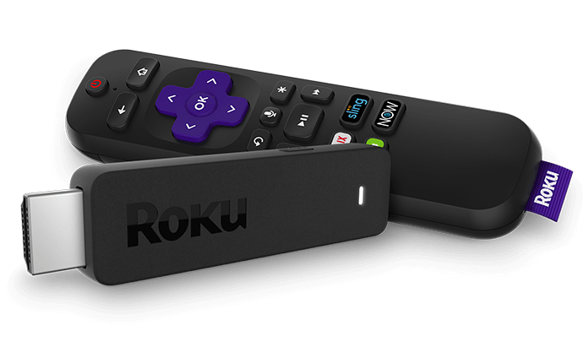](https://www.roku.com/en-gb/)